Victor Hugo Brandao

200606092@student.georgianc.on.ca

Descriptive & Inferential Statistic Analysis

Final part of a cumulative project conducting

a comprehensive dataset for analysis in MS Excel

Airbnb listings - Toronto

Data Exploration Part Final

Table of Contents

Data source description 2

Motivation for analysis of this dataset 2

Data dictionary 3

Data cleaning 4

Data coding 7

Outliers 8

Ranges, limitations, and assumptions about the dataset 10

Additional Data Needs 12

FINER research questions 12

Univariate descriptive statistics 12

Risk Ratio/Odds Ratio, Chi-Square Test and ANOVA 15

Risk Ratio/Odds Ratio 15

Chi-Square Test 17

ANOVA 18

Correlation & Regression 19

Correlation 19

Regression 20

Key findings 22

Conclusion 22

References 23

# Data source description

This dataset was obtained from the website *Inside Airbnb*. This website was launched by Murray Cox in 2016. It reports and visualizes scraped data on the property rental marketplace company Airbnb, focusing on highlighting illegal renting on the site and gentrification caused by landlords buying properties to rent on Airbnb (Wikimedia Foundation Inc., 2023).

The dataset used for this research was extracted on January 8th, 2024. It contains detailed information about accommodations located in Toronto, and was extracted from a .csv file containing over 20,000 rows and 75 variables. The variables include listing and host details, calendar availability, and review score. The dataset contains a good mix of qualitative and quantitative data types, including at least one of each NOIR data scale.

For this report, the number of variables was limited to 26, and all information related to calendar availability was excluded from the analysis. More information about the criteria of inclusion and exclusion is available in the “*Data cleaning*” section of this report.

The original dataset is available in the sheet named “originalData” in the .xlsx file attached to this report.

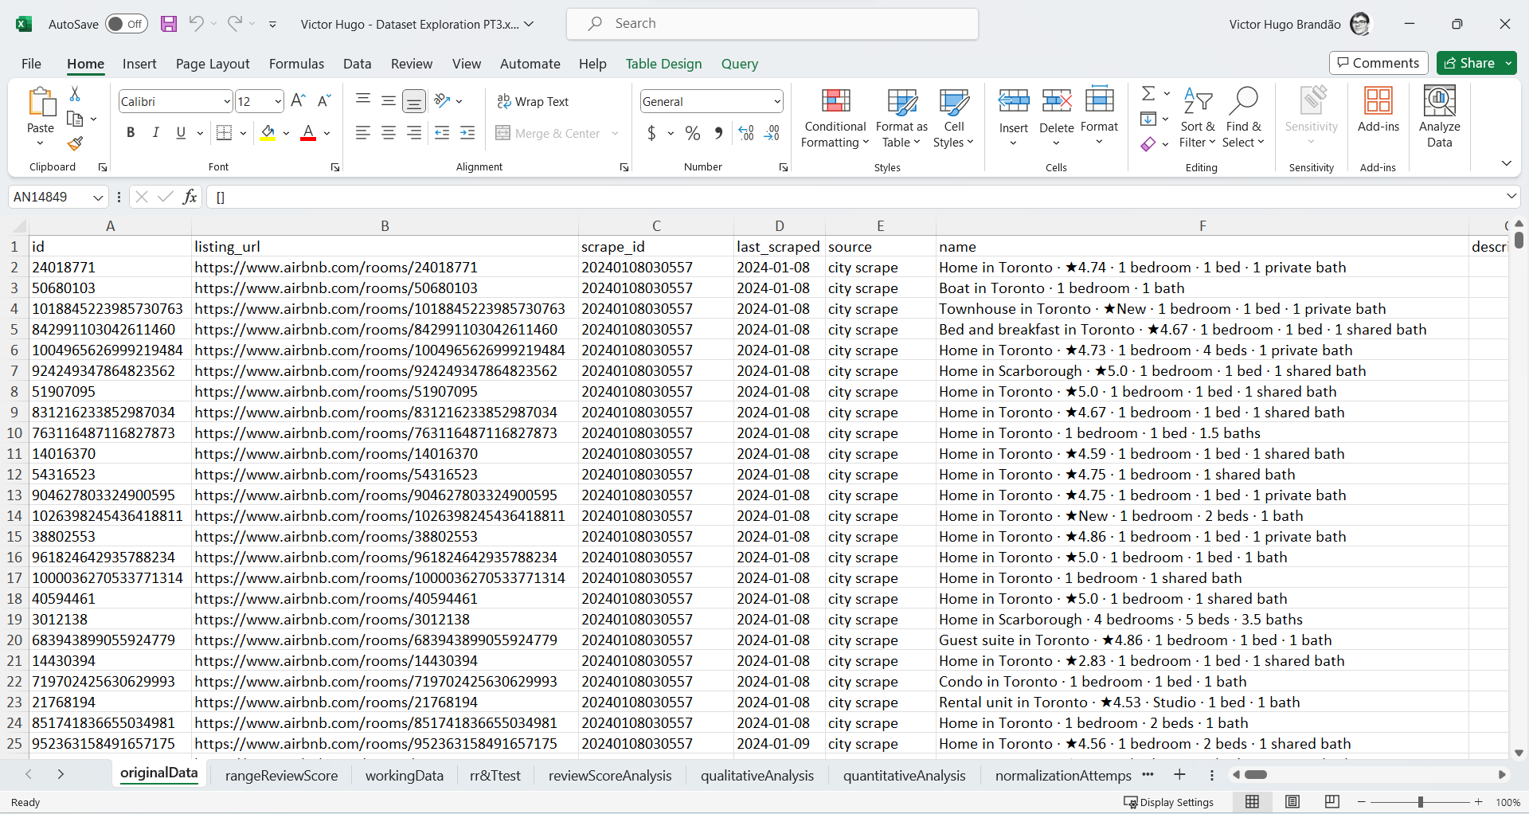

Figure 1. Overview of the original dataset imported to MS Excel available on “originalData” sheet

# Motivation for analysis of this dataset

The way people search for recommendations for products and services online is changing. According to reports from Google executives and independent surveys, younger generations are less likely to rely on search engines and prefer to use alternative platforms such as social media to find genuine recommendations (Fortune Media, 2022; Goodwin, 2023).

Companies from many different industries, including Amazon, Airbnb, Glassdoor, Uber, and Walmart, use a 5-star review scoring system as a strategic approach to building trust and offering users authentic reviews. However, this methodology comes with its share of drawbacks and criticisms. Ratings are prone to “grade” inflation, and many researchers believe that an overwhelming number of positive reviews renders star ratings unreliable (Breinlinger, Hagiu, & Wright, 2019; The Guardian, 2021).

This dataset was selected due to the author's familiarity with the subject, company, and industry. For the past six years, the author has worked in the travel and tourism industries in various roles such as customer support at Airbnb and Booking.com, sales, and operations departments in smaller companies.

The primary goal of exploring this dataset is to leverage the author's expertise to extract meaningful insights from a large volume of data and analyze the implications of the 5-star review scoring system in the digital space. Additionally, this dataset provides an overview of the short-term rental market in Toronto.

# Data dictionary

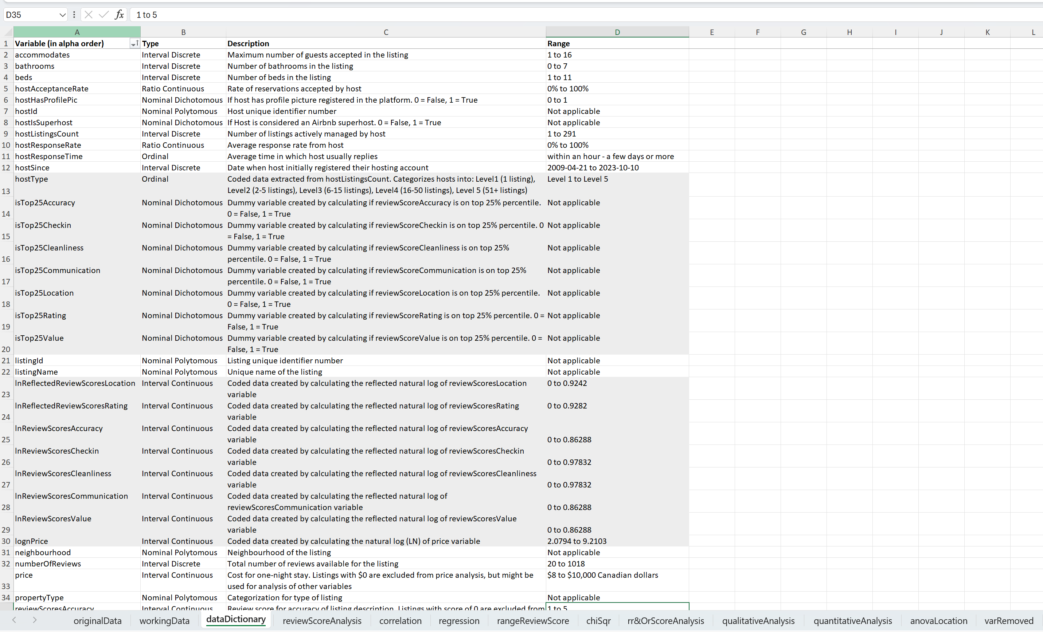

Figure 2. Updated data dictionary, with calculated variables highlighted

# Data cleaning

This report excluded 49 variables based on the following criteria:

* Links to websites;
* Blank and null columns;
* Any variable related to calendar availability;
* Any variable related to the process of scrapping data;
* Descriptive host information;
* Descriptive listing information.

All the sheets and variables were converted to Camel Case to facilitate data manipulation using programming languages such as Python and C#.

Some numbers available in the report were converted to text due to a limitation in the software MS Excel. Excel follows the IEEE 754 specification for how to store and calculate floating-point numbers. Excel therefore stores only 15 significant digits in a number and changes digits after the fifteenth place to zeros (Microsoft Corporation, 2022). This should not affect the process of data analysis since both variables affected (*listingId* and *hostId*) are nominal.

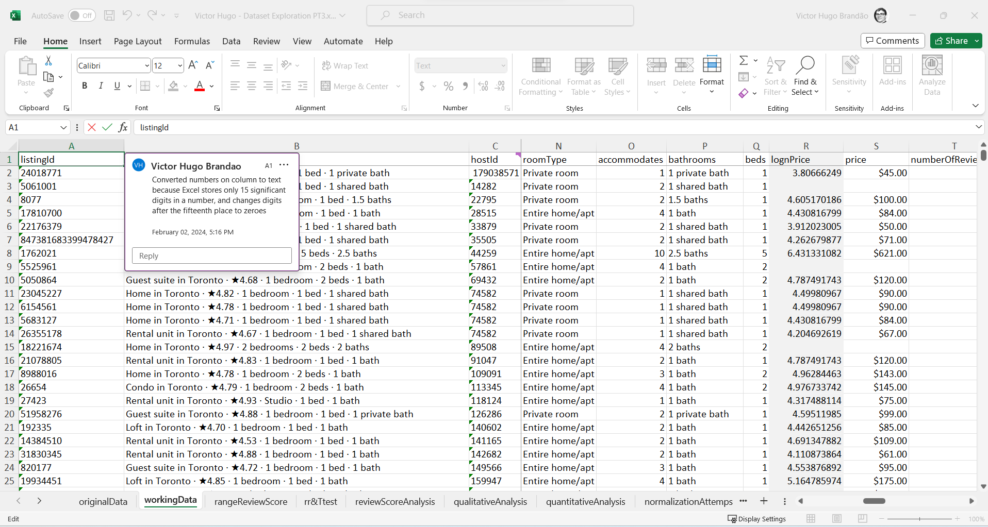

Figure 3. Illustration of column containing numerical data stored as text and comment

To facilitate data visualization, independent variables were moved to the left. The first row (labels) and first three columns *(listingId, listingName* and *hostId*) were frozen. The type of data in each column was converted to the most appropriate format (date, number, general, percentage or text), allowing analysis using the MS Office Analysis ToolPak Add-in. Columns with calculated fields were coloured with a shade of grey to distinguish them from other variables.

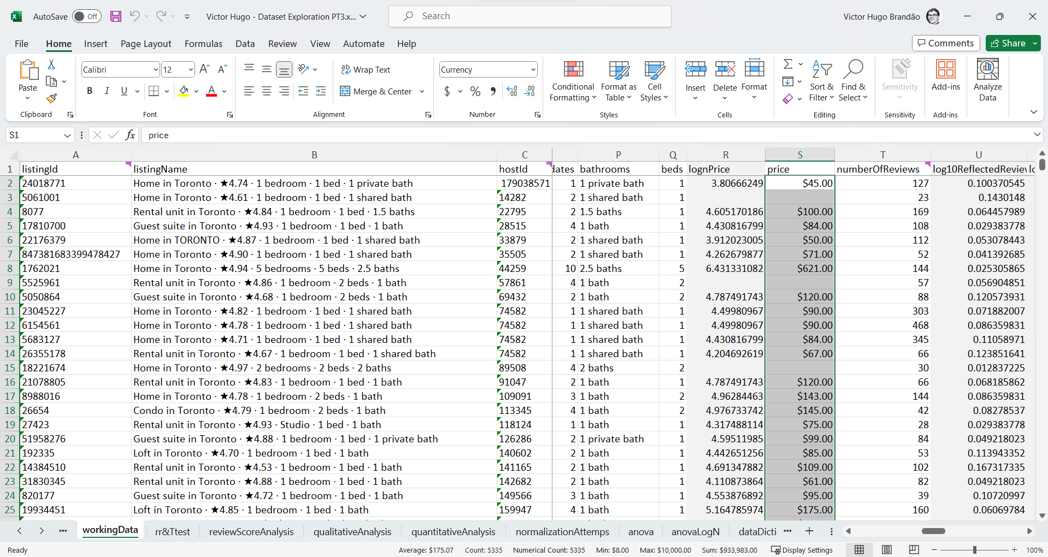

Figure 4. Demonstration of the use of MS Office Analysis ToolPak Add-in in the price column

Another step taken to ensure consistency in the statistical analysis was to exclude listings with less than 20 reviews. The result of this decision was a reduction in the number of listings analyzed from over twenty thousand to a little less than six thousand. This decision was taken after carefully considering the descriptive analysis of the review scores and observing the range of review scores per number of reviews. All the review scores were very leptokurtic and negatively skewed, and regular methods to normalize the distribution (log, square, root) did not provide satisfactory results, which in turn made the application of standard statistical analysis impossible.

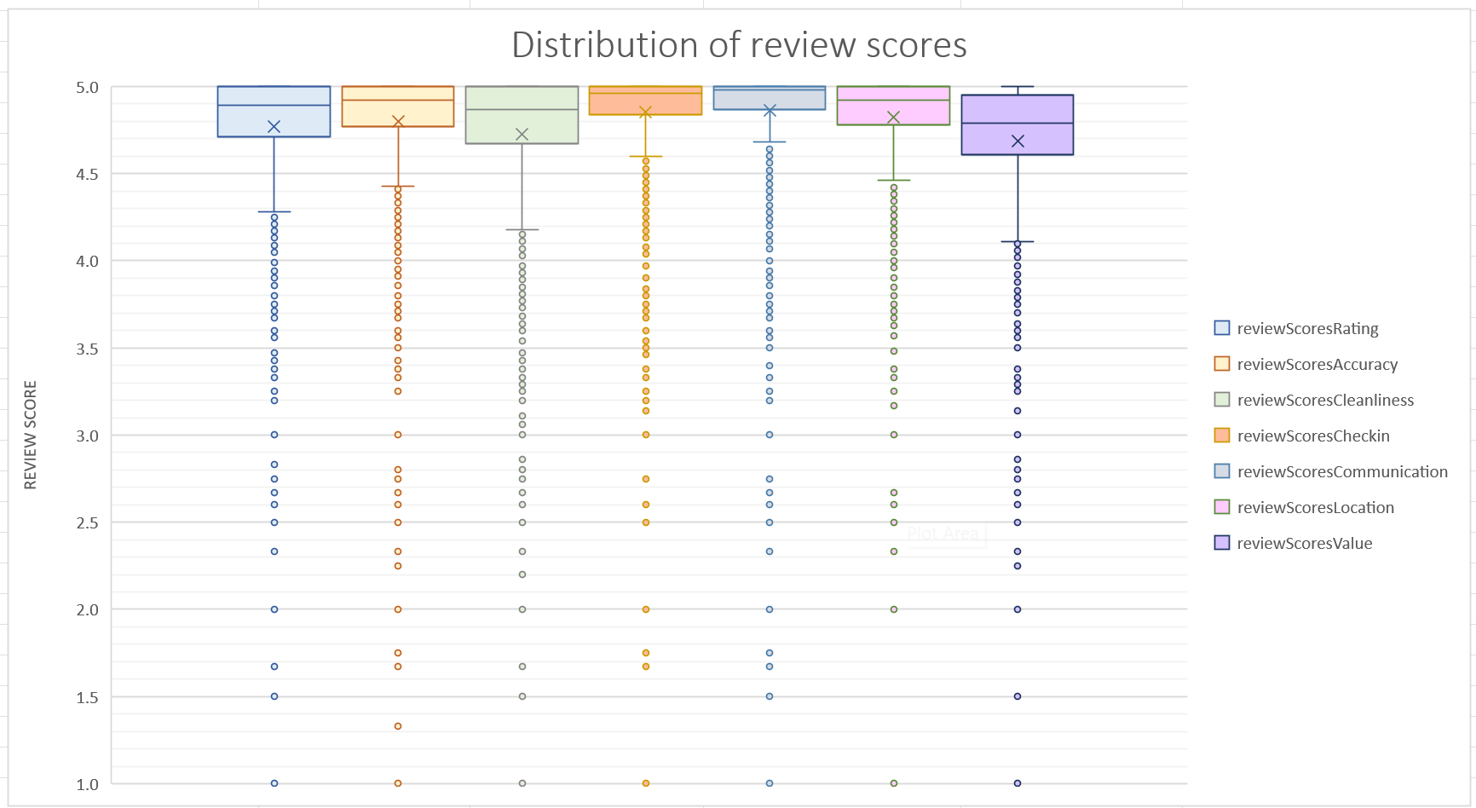

Figure 5. Box chart showing the distribution of all seven review score categories, prior to data cleaning

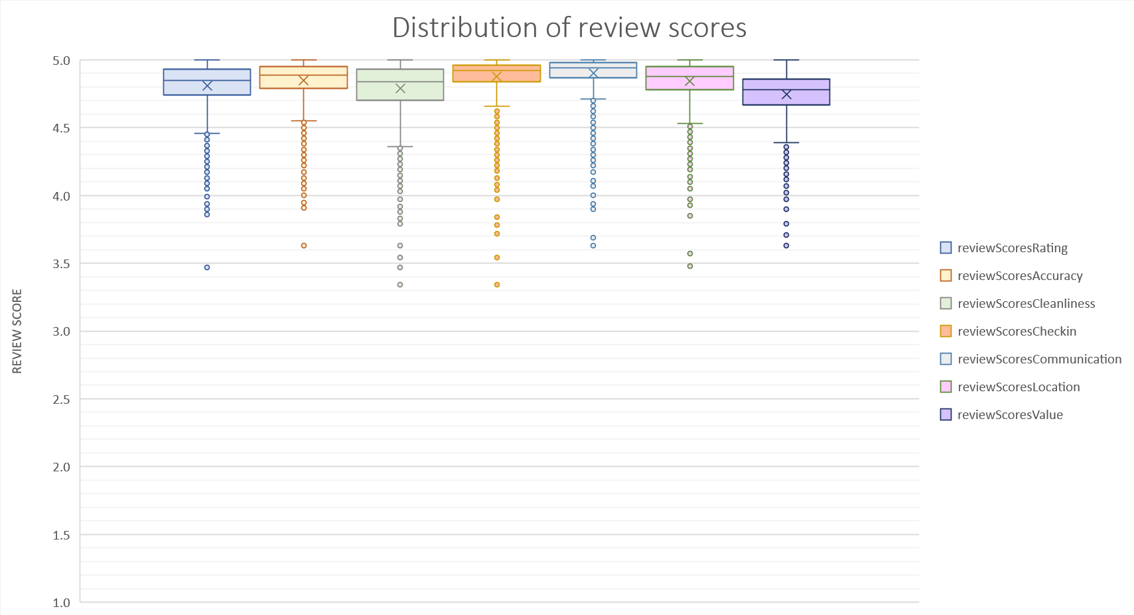

Figure 6. Box chart with the distribution of all seven review score categories, excluding listings with less than 20 reviews

Upon further investigation, it was clear that listings with less than 20 reviews were having a significant impact on the distribution of review scores, presenting a very high degree of variance. The breakpoint of 20 was chosen due to its consistency, with overall less than 1 point of difference between highest rated listing to lowest rated listing. This pattern of homogeny of reviews became even more evident as the number of reviews went up.

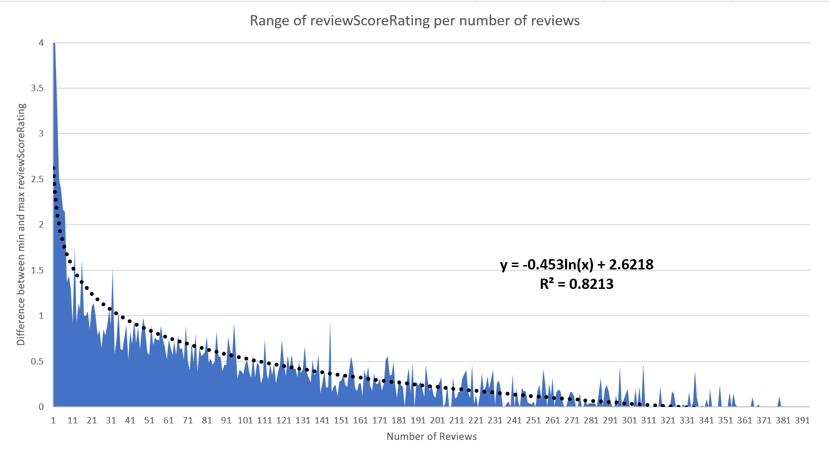

Figure 7. Representation of difference between max an min review score, per number of reviews

## Data coding

As part of the data cleaning process, sixteen variables were coded for analysis. The categorical variables hostIsSuperhost and hostHasProfilePic were coded one-for-one, where the values "f" (false) and "t" (true) were replaced with 0 and 1 respectively. This was done to facilitate basic mathematical operations using MS Office Analysis ToolPak.

For example, the SUM of 6731 in the variable hostIsSuperhost indicates that the same number of listings were from a host with Superhost status. Similarly, the average of 0.54 in this variable implies that 54% of the listings with 20 or more reviews are managed by someone with Superhost status.

Other calculated variables include the reflected natural log for all categories of review scoresand *lognPrice*. They were created as an effort to normalize the distribution of other variables to perform statistical tests such as ANOVA. The variables *isTop25* categories were created to perform a risk ratio/odds ratio analysis, evaluating differences between review scores of Superhosts and non-Superhosts.

The variable *hostType* was coded based on *hostListingsCount*. The goal of this coding was to create a “user persona”, a tool commonly used by organizations to better understand the target audience. The author of this report used his experience working in Community Support teams in Airbnb and Booking.com to create this categorization. The following is a description of the criteria for each level and the reasoning behind it:

* **Level1** - host manages a single listing. Hosts may use Airbnb as a side gig to generate some extra income. Listing is likely managed by one person, using the Airbnb platform.
* **Level2** - host manages between two to five listings. Hosts may rely on Airbnb as a supplementary source of income. Managing these listings is feasible solely through the Airbnb platform.
* **Level3** - host manages between six and fifteen listings. Airbnb is a major income source, requiring the use of sophisticated software to manage calendar availability. Co-hosts may assist in successfully running multiple listings.
* **Level4** - host manages between sixteen and fifty listings. Higher organizational demands exist. In addition to utilizing third-party software, the host may have a small staff structured similarly to a boutique hotel, including roles like property manager, cleaning staff, and reservation manager. Listings contribute to the income of multiple individuals.
* **Level5** - host manages 51 listings or more. The host is likely part of a company with a structure akin to a conventional hotel or a large enterprise, showcasing a significant and sophisticated operation.

## Outliers

During the process of analyzing the dataset and conducting univariate descriptive statistics, very few evident outliers were identified. From the variables that can be modified by Airbnb users, most of them are within a range or based on a scale. Only the variable price could be selected as “free-form”. Of 16595 rows with price value, only 8 were considered unsuitable/invalid for price analysis.

Some listings had prices as low as $8/night, up to $12,400/ night. After manually verifying the first three listings with the lowest cost, it was verified that the first two had their cost updated to over $100/night. Surprisingly, the 3rd property with a cost of $14/ night was active and available for rental. The listing had a restriction of a minimum 28-nights rental and, with additional taxes and fees, had a cost that is very low but feasible, based on the author’s experience.

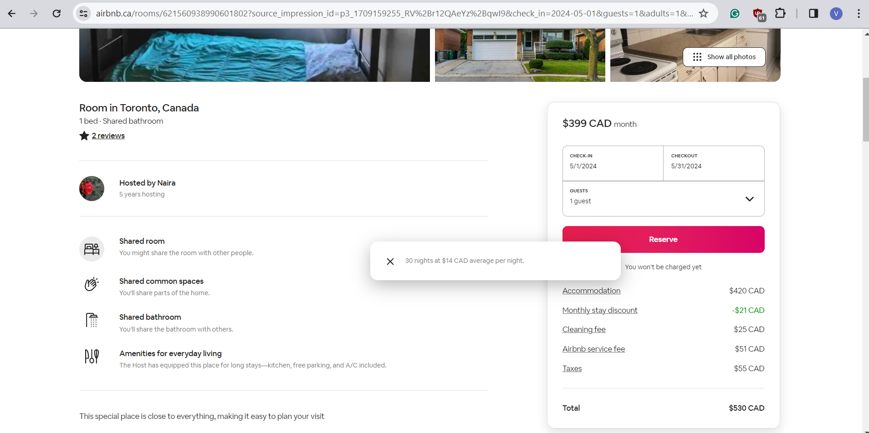

Figure 8. Listing with the lowest feasible price per night, as shown on Airbnb’s website.

In the upper price range, some listings could reach the nightly rate of $10,000. After manually verifying the listing, it is unlikely that the price is an accurate representation of its value. While the apartment is in a convenient location and has a great view, the cost fairly exceeds what is considered reasonable for a bachelor's apartment. In this author’s experience, some hosts may increase the price of a listing’s nightly rate to unreasonable prices as a workaround to availability issues (not knowing or being unable to close the listing’s calendar).

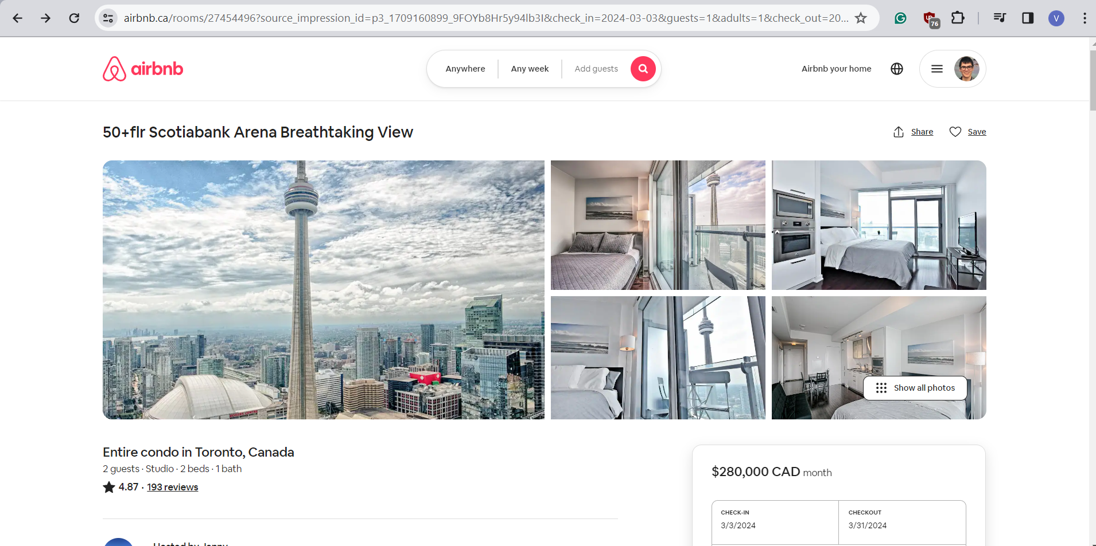

Figure 9. Listing with the highest price per night, as shown on Airbnb’s website. The price point is unreasonable for the product

The top three listings in terms of the highest price per night appeared to be overpriced when compared to the accommodation they provided. However, the fourth most expensive listing seemed to offer accommodations that were reasonable for its price. Based on this research, we can consider this property to be the most expensive option available.

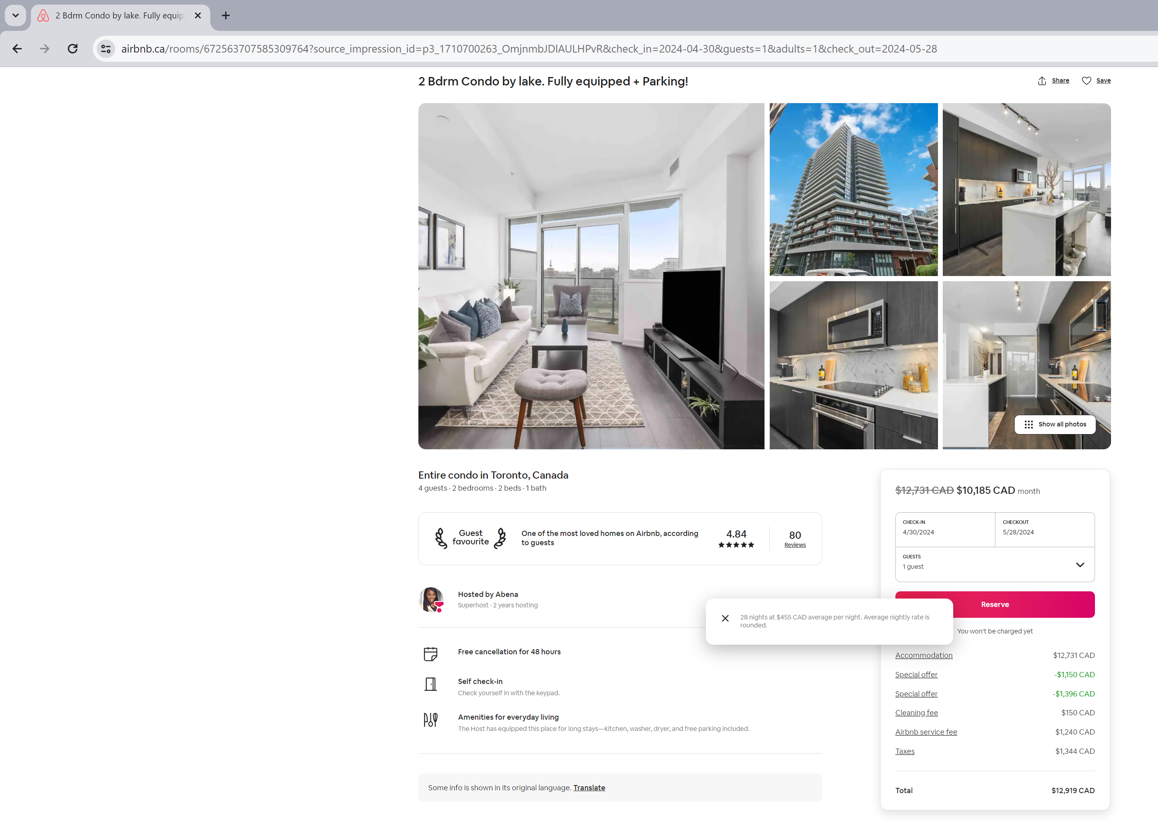

Figure 10. Listing with the highest feasible price per night, as shown on Airbnb’s website

# Ranges, limitations, and assumptions about the dataset

The first limitation of this dataset is related to the method of extraction. This is an unofficial database obtained via the process of web scraping. While the legality and ethics of web scrapping might be controversial, governmental entities in Canada such as Statics Canada use this method to acquire information for their databases (Statistics Canada, 2023). Setting these topics aside, it is important to keep in mind that this process of extracting data is not flawless. For the sake of this exploration, we will have to assume that the data is accurate and reliable.

While not explicitly stated anywhere on the website or dataset, the large amount of data indicates that this data is related to the entire population of Airbnb listings in Toronto.

During the process of data cleanup, it was verified that some of the data related to the variable price was missing. A property cannot be available for rent on the Airbnb platform without having a price, so the property must be either unlisted (not available for rent) or there was an error in the extraction of this data by the dataset provider. Since these listings still have valuable data for exploration (such as review scores) we will assume that they are unlisted.

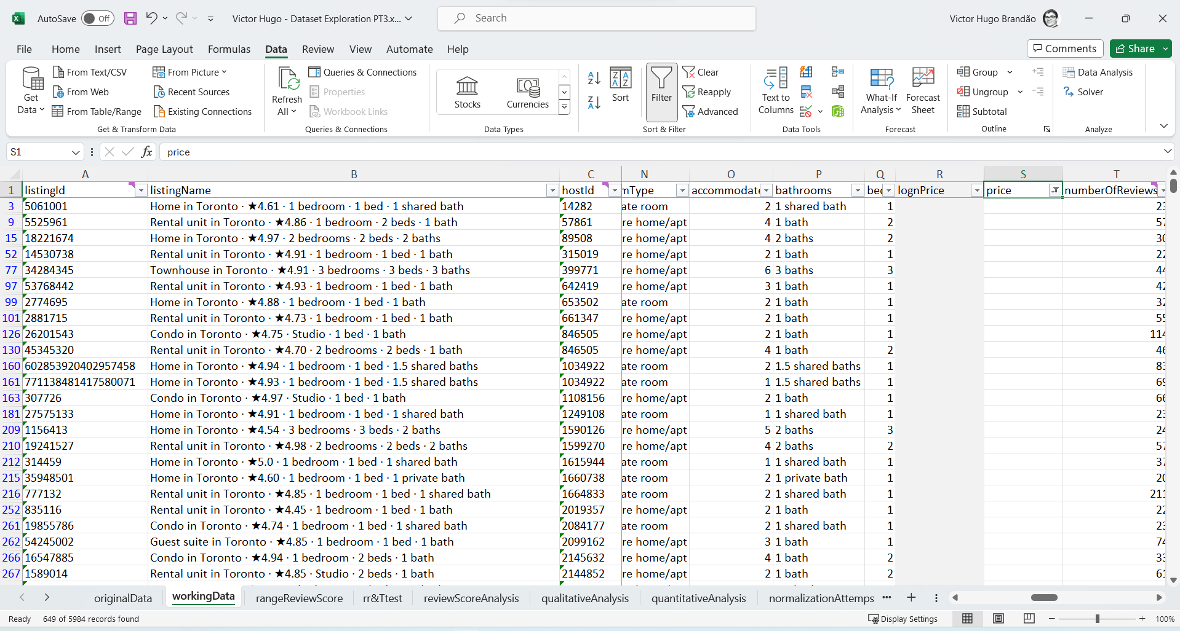

Figure 11. Overview of “workingData” sheet filtering all Blanks (649) on the variable price

While the units of measurement for most variables are intuitive for this author, the price variable is the most complex to analyze. Upon accessing the Airbnb platform via the links provided, it was possible to confirm the amount matching the value in currency CAD. However, the amount does not include additional charges such as cleaning fees, Airbnb service fees and taxes. The price variable also does not reflect price adjustments related to discounts, such as weekly and monthly stays.

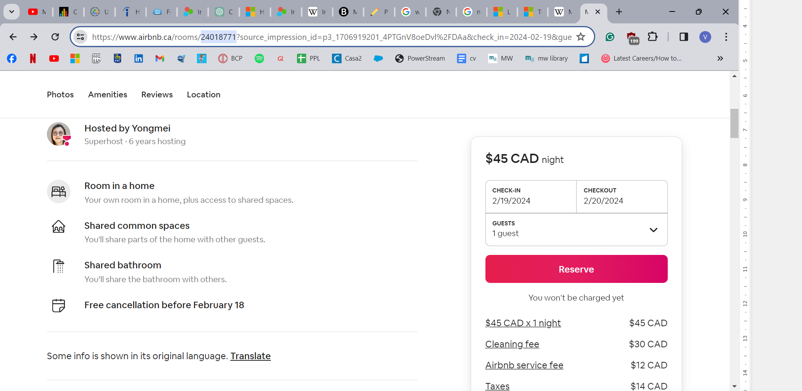

Figure 12. Price details of listing 24018771 on the Airbnb platform

## Additional Data Needs

To conduct a precise analysis of how price affects other variables, more information about additional fees would be required. Although some data like government taxes and Airbnb's service fee can be estimated based on official sources, the cleaning fee is determined by each host and can significantly impact the final cost, especially for short stays. Given this fact, no relational statistical tests were applied using price due to the potential of misleading results.

In order to increase the accuracy of the information gathered during this investigation, it would be beneficial to compare current Airbnb datasets from Toronto with previous ones. By examining historical data, we can identify trends and shifts in the market. Additionally, analyzing Airbnb data from other cities would provide insight into how people behave in different areas and how regulations impact the variables.

We can also compare Airbnb's data in Toronto with other digital platforms, such as Glassdoor, Amazon, and Uber, which also use a 5-star rating system. This comparison could help us understand how people use the rating system and how it impacts their buying decisions and brand loyalty. In the digital world, the 5-star rating system is crucial for building trust with consumers.

# FINER research questions

1. How strongly do various aspects of guest ratings (e.g., accuracy, cleanliness, communication) correlate with overall rating scores in Airbnb listings in Toronto?
2. To what extent can the overall rating score of Airbnb listings in Toronto be predicted based on specific aspects of guest ratings (accuracy, cleanliness, communication, etc.), as revealed by regression analysis?
3. Is there a significant association between host response time and a higher review score for communication?
4. What are the relative ratios of achieving high ratings (e.g., rating, accuracy, cleanliness) for Superhost-designated hosts compared to non-Superhosts in Toronto Airbnb listings? How does this differ across different aspects of guest ratings?
5. Are there statistically significant differences in scores for location among the top 10 neighbourhoods with the highest frequency of listings in Toronto?

# Univariate descriptive statistics

The information presented in the images below relates to the analysis included in the worksheet named "reviewScoreAnalysis" of this report. All the findings from this univariate descriptive analysis have been gathered from the entire population of listings that have received 20 or more reviews and meet all the criteria specified in the data cleaning section of this report.

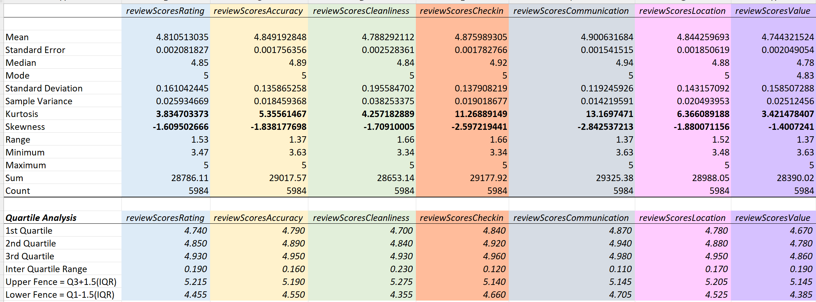

Figure 13. Table with descriptive statistics for all seven review score categories

Here we can visualize the result of descriptive statistics applied to all review score categories. While the analysis was univariate, each variable was calculated individually, all the results were organized next to each other to facilitate visualization.

None of the variables analyzed present a normal distribution. Many of the common methods of statistical analysis cannot be applied to this shape such as ANOVA, t-test, and regressions. The mean and median are very close to the upper limit of the range, and the mode is the maximum for all six variables. The variables are very Leptokurtic, with a long-tailed distribution and negatively skewed.

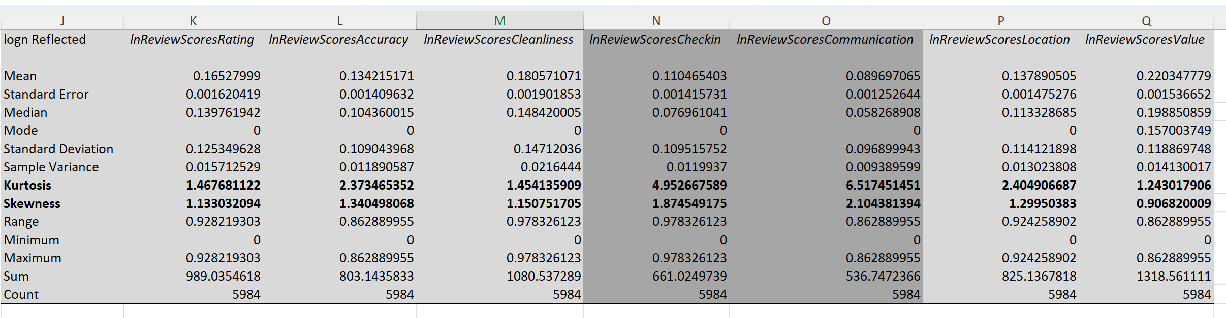

Figure 14. Table with descriptive statistics for all seven review score categories after reflected log-normal transformation

The outcome of the reverse log-normal transformation for various variables is provided above. Most of the variables had a kurtosis and skewness close to the normal distribution (<2.5). However, the review scores for check-in and communication did not meet this criterion. Although statistical tests of RR/OR, correlation, and regression will be applied to all variables, the results for the variables that did not meet the criterion will be interpreted with caution and cannot be considered statistically valid.

The univariate analysis of the qualitative variables *neighbourhoods*, *propertyType* and *roomType* is available in the worksheet *qualitativeAnalysis* of this report.

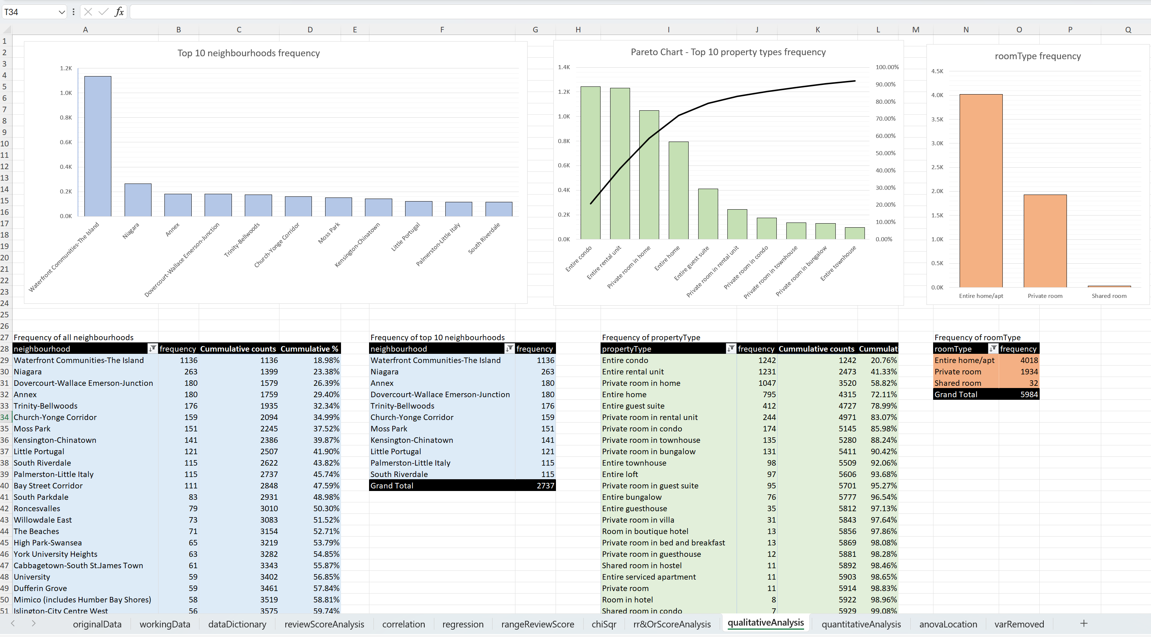

Figure 15. Tables, Pareto chart and bar charts with the frequency distribution of categorical variables

This is due to Little Italy and South Riverdale both having the same number of observations (115) and therefore sharing the 10th place. The total number of Airbnb listings across the Top 10 neighbourhoods in Toronto is 2737, accounting for 45% of the total number of listings in all 140 neighbourhoods. The neighbourhood with the highest number of listings is Waterfront Communities – The Island, which represents almost 19% of the total number of listings with 20 or more reviews.

Since these variables were categorical, the statistical methods that can be applied to analyze the data are limited to frequency distributions.

An interesting fact about the dataset is that it includes information on a total of 140 neighbourhoods in Toronto. The current number of official Toronto neighbourhoods is currently 158, as per sources from the city of Toronto (City of Toronto, 2024). Toronto’s neighbourhoods numbered 140 from the late 1990s to March 2022, when some neighbourhoods were split because of exceedingly high population growth. The top 1 neighborhood in this dataset, Waterfront Communities-The Island, was split into two: Harbourfront-CityPlace and St Lawrence-East Bayfront-The Islands. Based on these results, it should be safe to assume that Airbnb uses old neighbourhood data obtained prior 2022.

Another important insight can be obtained from analyzing the variable *room type*. Most listings available on this dataset are for the entire home/apartment, almost twice as much as private and shared rooms. This raises an interesting question: why do the listings rented have this distribution? We can formulate some hypotheses, such as hosts being more comfortable renting a vacant property rather than sharing their home with strangers, however, the investigation of this kind of hypothesis is most likely outside the scope of this dataset.

The final Univariate descriptive statistics conducted for this part of dataset exploration were related to the variables *hostListingsCount* and *price*.

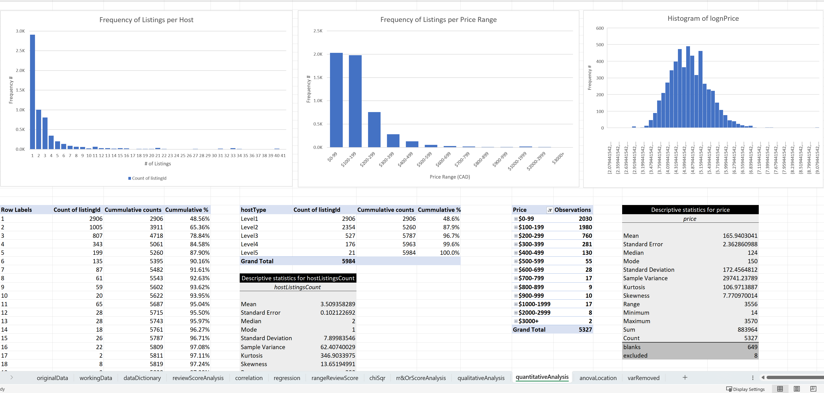

Figure 16. Tables and bar charts analyzing qualitative variables

One of the key insights gained from this analysis is related to the frequency of listings per host. It was found that around 78.84% of the listings in this dataset are managed by hosts who have a maximum of three listings on the platform. This distribution was one of the primary reasons to create a new variable for user personas represented by hostType. This shows that most people on the platform use it to earn extra income without needing any third-party software to manage their listings or hire additional staff.

The statistics for hostListingsCount and price appear to be as expected. Although, at first glance, the mean price seems lower than anticipated, it can be inferred that the guest price is likely to be higher after accounting for cleaning fees, Airbnb fees and taxes. While the variable lognPrice has a somewhat normalized distribution, making it ideal for statistical analysis, it will not be examined further due to the reasons explained in the section "Additional Data Needs" of this report.

# Risk Ratio/Odds Ratio, Chi-Square Test and ANOVA

## Risk Ratio/Odds Ratio

To investigate the research question “*What are the relative ratios of achieving high ratings (e.g., rating, accuracy, cleanliness) for Superhost-designated hosts compared to non-Superhosts in Toronto Airbnb listings? How does this differ across different aspects of guest ratings?*”, both Risk Ratio and Odds Ratio tests were performed using the variables *hostIsSuperhost* and *isTop25* for each review score variable*.*

To answer this question, the (null) hypothesis being tested is: “There is no difference in the relative ratios of achieving high ratings between Superhost-designated hosts and non-Superhosts in Toronto Airbnb listings across different aspects of guest ratings.”

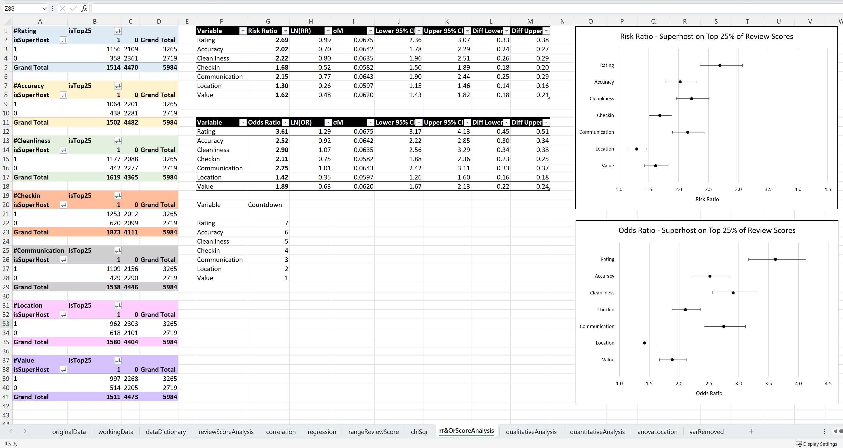

Figure 17. Table and forest plots with results of risk ratio and odds ratio available on rr&OrScoreAnalysis worksheet

It is debatable whether odds or risk ratios are more appropriate for this analysis. The analysis is limited to about one-third of the original dataset as listings with less than 20 reviews were excluded from the analysis, making it a sample. However, it can also be argued that this data represents a population comprising all listings with more than 20 reviews.

Despite the suitability debate, both tests yielded similar results. The figure above indicates that the pattern observed in both tests is interchangeable, even though the range of ratios differs between tests.

The analysis of relative risk and odds ratio shows that Superhosts have significantly higher ratios for achieving high ratings across all aspects compared to non-Superhosts, indicating that they consistently outperform non-Superhosts in terms of guest satisfaction.

The strongest associations between Superhost status and review scores are in the areas of overall rating score, accuracy, cleanliness and communication, while weaker associations are observed in the areas of check-in, location and value.

It is important to note that the classification of Superhost can be a confounding variable as Superhosts are required, by definition, to have a high average of overall review scores. To become a Superhost, users are required to meet the following criteria:

* Completed at least 10 trips or 3 reservations that total at least 100 nights
* Maintained a 90% response rate or higher
* Maintained a less than 1% cancellation rate, with exceptions made for those that fall under our Extenuating Circumstances policy
* **Maintained a 4.8 overall rating** (A review counts toward Superhost status when either both the guest and the Host have submitted a review, or the 14-day window for reviews is over, whichever comes first).

The test results have shown that being a Superhost on Airbnb is strongly associated with higher ratings across various aspects of guest satisfaction. However, it's important to consider some key factors. Both the risk ratio and odds ratio tests have returned significant results for all variables analyzed. Since there is a clear difference in the relative ratios of high ratings achieved by Superhosts and non-Superhosts, the null hypothesis can be rejected.

## Chi-Square Test

A Chi-Square test was conducted to determine if there is a significant relationship between the response time of a host and a higher review score for communication. The null hypothesis states that there is no significant association between the two variables. The variables examined in this study were *hostReponseTime* and *isTop25Communication*.

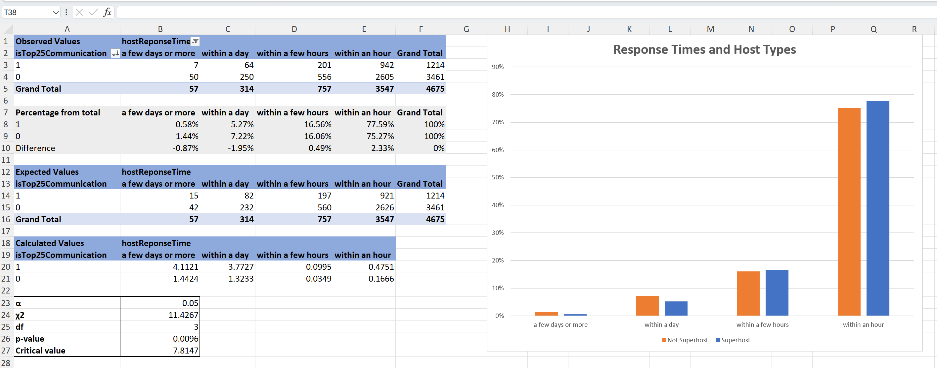

Figure 18. Table and bar chart with results of Chi-Square test applied on variables hostReponseTime and isTop25Communication.

The p-value (0.0096) is less than the significance level (α = 0.05), indicating that there is a statistically significant association between host response time and a higher review score for communication. This suggests that there is strong evidence to support the existence of a relationship between these variables, and consequently to reject the null hypothesis.

The calculated chi-square statistic (11.4267) exceeds the critical value (7.8147) for a significance level of 0.05, further supporting the rejection of the null hypothesis.

Based on the findings, it seems that the amount of time taken by an Airbnb host to respond to inquiries from guests is a key factor in determining the review scores of their listings in Toronto. However, this test alone is not enough to determine the extent of the impact that a change in this factor would have on the overall score. The bar chart that shows the percentage of answers within each category by the top 25 percentile and bottom 75 percentile may suggest that the impact could be minimal, but other statistical tests might be necessary to get a more precise estimate.

## ANOVA

The ANOVA test was applied to the variables *neighbourhoods* and *lnReflectedReviewScoresRating* to answer the research question “Are there statistically significant differences in scores for location among the top 10 neighbourhoods with the highest frequency of listings in Toronto?”.

To conduct the test, a table was constructed that included all instances of the calculated variable in each of the neighbourhoods. As there were a total of 140 neighbourhoods, only the Top 10 neighbourhoods with the highest frequency were analyzed. The results of this analysis can be found in the *anovaLocation* worksheet.

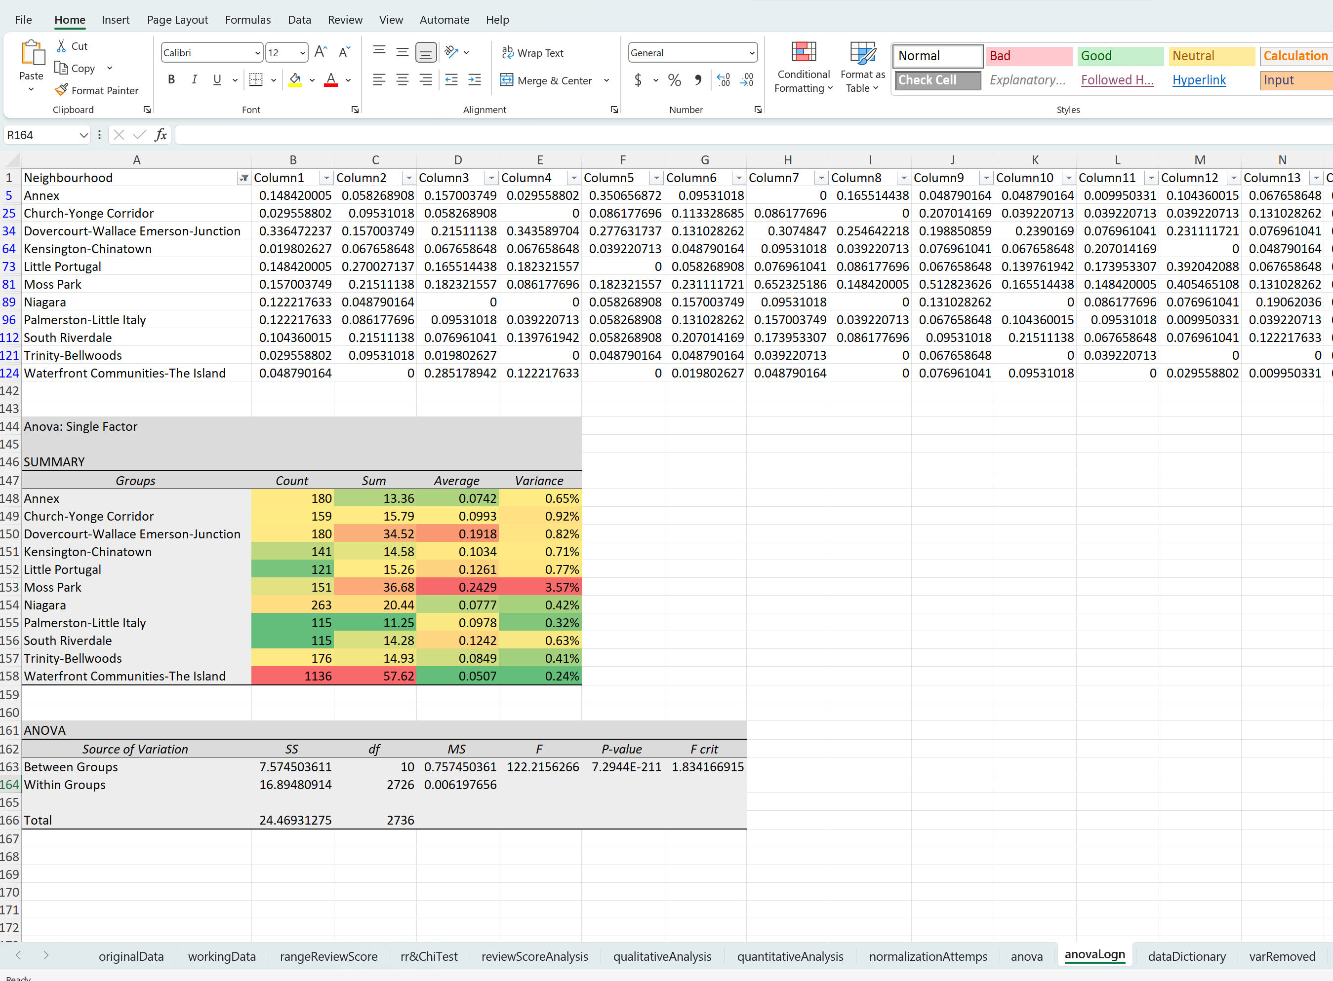

Figure 19. Table and results of ANOVA test applied on neighbourhood and lnReflectedReviewScoresRating

Based on the ANOVA results, the p-value associated with the F-statistic (122.2156) was found to be less than the significance level (p<0.05), indicating that there is sufficient evidence to reject the null hypothesis.

The SS (Sum of Squares) and MS (Mean Square) values for "Within Groups" are substantially smaller than the values for "Between Groups". This indicates that the variability within listings in the same neighbourhood is relatively small compared to the variability between neighbourhoods. This test does not provide us with any indication of causation, but this insight can be quite valuable for hosts looking to purchase a property to lease on Airbnb.

# Correlation & Regression

## Correlation

This study applied the Pearson correlation test to examine the correlation between various aspects of guest ratings (e.g., accuracy, cleanliness, communication) and overall rating score of Airbnb listings in Toronto. The results are available in the figure below.

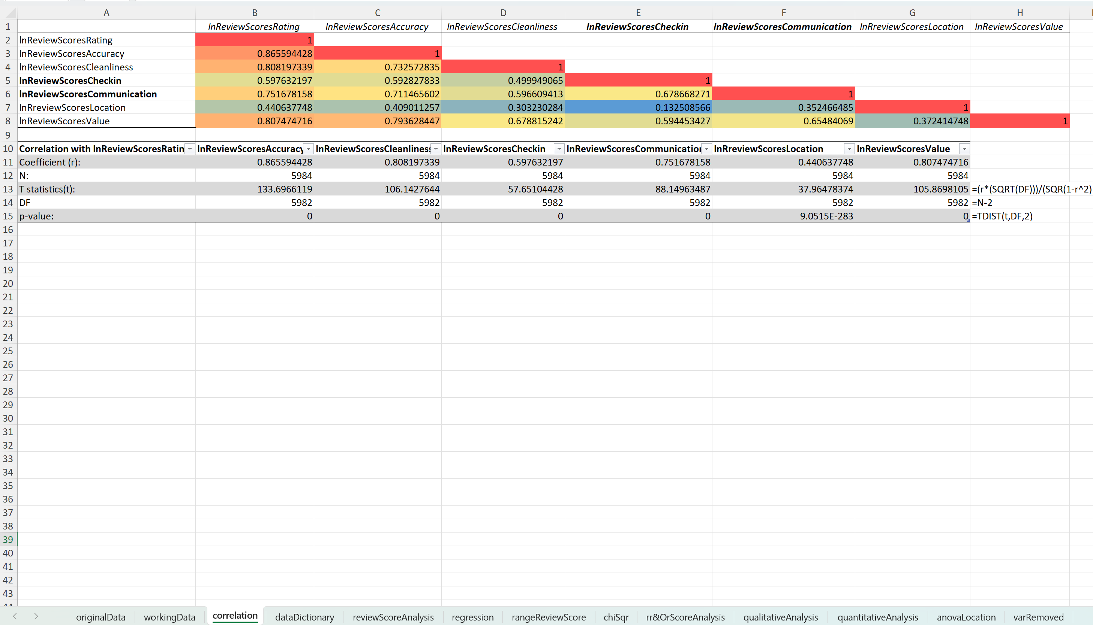

Figure 20. Table and results of Pearson correlation test applied on reflected natural of review scores variables

Before starting the discussion, it’s important to highlight that correlation analysis assumes that the variables being analyzed are normally distributed. Since the variables, lnReviewScoresCheckin and lnReviewScoresCommunication deviate significantly from normality, even after transformation, the validity of the correlation coefficients of these variables might be inaccurate.

Accuracy (r = 0.865), cleanliness (r = 0.808), communication (r = 0.752), and value (r = 0.807) exhibit strong positive correlations with lnReviewScoresRating. This suggests that higher ratings in accuracy, cleanliness, communication, and value are associated with higher overall rating scores. Check-in (r = 0.598) has a moderate positive correlation with the overall rating, while location shows a weak but still positive correlation.

The p-values associated with the correlation coefficients are all very close to zero, which indicates that the correlations observed between various aspects of guest ratings and overall rating scores are statistically significant. This suggests that the relationships between the different aspects of guest ratings and overall rating scores are unlikely to be due to random chance. Therefore, we can reject the null hypothesis.

These findings have practical implications for Airbnb hosts and property managers in Toronto. By understanding the factors that contribute most strongly to overall rating scores, hosts can prioritize improvements in areas such as accuracy, cleanliness, communication, and value to enhance guest satisfaction and boost their Airbnb ratings. This targeted approach to guest experience management can lead to improved guest reviews, increased bookings, and ultimately, greater success in the Airbnb marketplace.

## Regression

In the previous section of this report, we identified the review variables that are strongly correlated with the overall review score. Additionally, one of the goals of this research is to determine the impact of these variables. The purpose of applying this regression test is to answer the question "To what extent can the overall rating score of Airbnb listings in Toronto be predicted based on specific aspects of guest ratings (accuracy, cleanliness, communication, etc.), as revealed by regression analysis?".

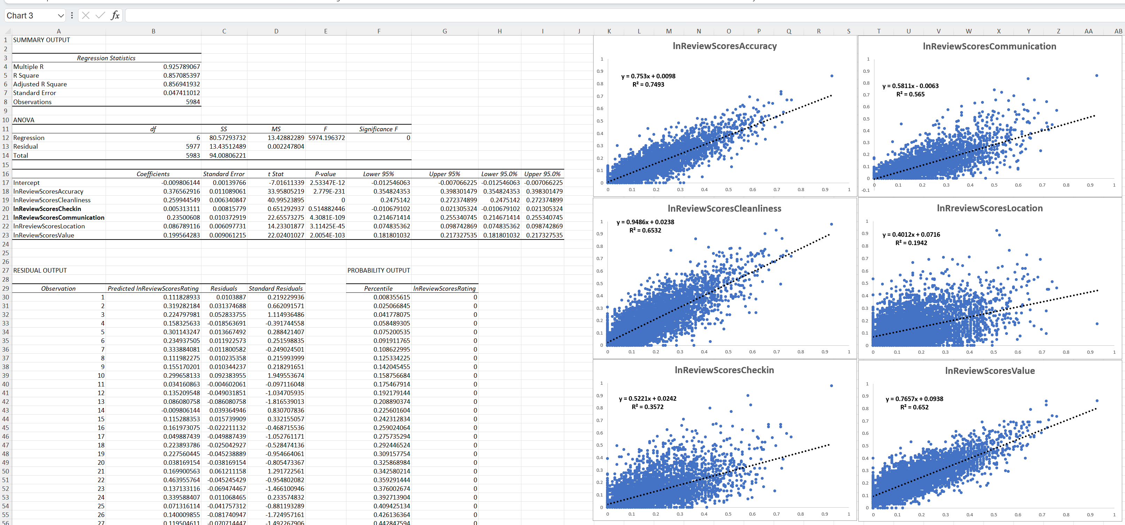

Figure 21. Table and scatter plots showing the results of linear regression analysis

The multiple R value of 0.925 indicates a strong positive correlation between the predictor variables (accuracy, cleanliness, communication, location, value) and the overall rating score. This suggests that there is a substantial relationship between these aspects of guest ratings and the overall rating of Airbnb listings in Toronto. The R-squared value of 0.857 indicates that approximately 85.7% of the variability in the overall rating score can be explained by the predictor variables included in the regression model.

There are certain review categories, such as accuracy, cleanliness, and value, that have a stronger positive correlation with the overall review score. We can identify the strength of these relationships by analyzing the individual coefficients of each predictor variable. Most of them had statistically significant coefficients with p-values < 0.05, except for the check-in category.

Although the summary statistics suggest that a linear regression model could be used to predict overall review scores based on specific categories, further analysis of the residual plot indicates that some assumptions of linear regression were violated.

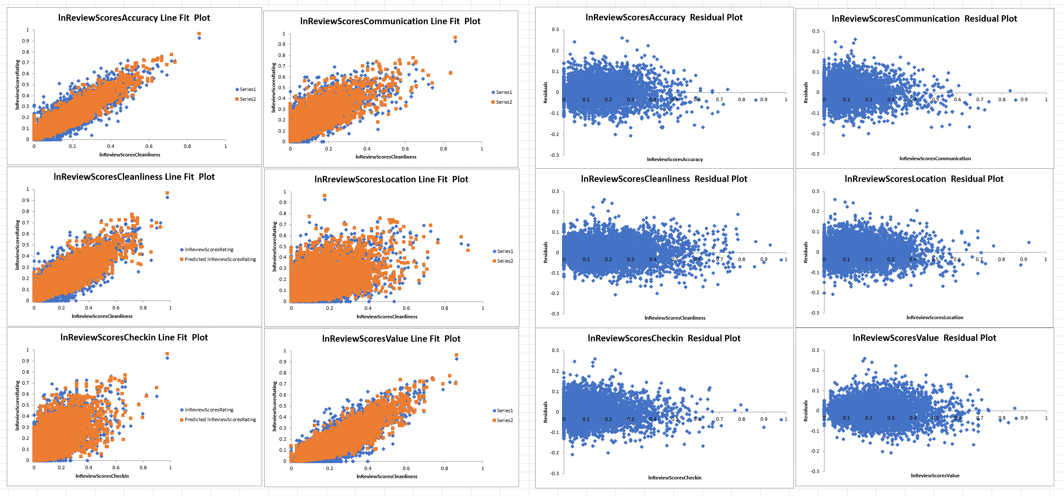

Figure 22. Scatter plots with best line fit and residuals of linear regression

The residual plot of the linear regression indicates that there is heteroscedasticity, which means that the residuals' spread differs across various levels of the predictor variables. “While heteroscedasticity does not cause bias in the coefficient estimates, it does make them less precise. Lower precision increases the likelihood that the coefficient estimates are further from the correct population value.” (Frost, 2024)

When there is heteroscedasticity in the data, it is important to be careful when analyzing the results of the regression analysis. Although the coefficient estimates are still unbiased, the values may not represent the actual estimates.

It is important to note that this shouldn't affect our null hypothesis, as it would not be possible to accept it due to the low p-value in the regression statistics. However, it is also important to note that we cannot use these formulas and coefficients to predict the overall review score accurately or estimate the degree of impact of each variable with high confidence.

# Key findings

* Listings with less than 20 reviews exhibited a high degree of variance of review scores, leading to unreliable and skewed results. After excluding these listings, the distribution of review scores became more homogeneous, allowing for more accurate analysis of guest satisfaction levels
* Superhost consistently outperformed non-Superhosts across all aspects of guest ratings, including overall rating score, accuracy, cleanliness, and communication.
* The strongest associations between Superhost status and review scores were observed in overall rating score, accuracy, cleanliness, and communication, while weaker associations were found in check-in, location, and value.
* A statistically significant association was found between host response time and higher review scores for communication.
* Variability between neighbourhoods was substantially greater than variability within neighbourhoods, suggesting that neighbourhood choice can impact Airbnb ratings.
* Strong positive correlations were found between accuracy, cleanliness, communication, value, and overall rating score.
* A linear regression formula might not be suitable to predict overall review score based on multiple review score categories

# Conclusion

Our analysis revealed strong correlations between various aspects of guest ratings, such as accuracy, cleanliness, communication, and overall rating scores. Hosts who excel in these areas are more likely to receive higher overall ratings, emphasizing the importance of prioritizing guest experience and service quality. Additionally, our investigation of the Superhost status demonstrated significant associations between Superhosts and higher review scores across multiple categories.

The distribution of listings per host revealed that the majority of hosts manage a small number of listings, suggesting that Airbnb is utilized mostly by individuals seeking supplemental income rather than large-scale property managers.

Our analysis also identified limitations and challenges, including the lack of in-depth information about pricing data and the exclusion of listings with low review counts. Also, the lack of analysis of other similar data sources from Airbnb and other online platforms makes it difficult to extrapolate these results.

In conclusion, this study provides valuable insights for Airbnb hosts and property managers in Toronto. While this kind of data may be challenging to manipulate, with a thorough understanding of the data and the application of appropriate statistical tests, it is possible to analyze it and draw meaningful conclusions that can support a data-driven decision-making process.

# References

Breinlinger, J., Hagiu, A., & Wright, J. (2019, July 02). *The Problems with 5-Star Rating Systems, and How to Fix Them.* Retrieved from Harvard Business Review: https://hbr.org/2019/07/the-problems-with-5-star-rating-systems-and-how-to-fix-them

City of Toronto. (2024, February 28). *About Toronto Neighbourhoods*. Retrieved from City of Toronto: https://www.toronto.ca/city-government/data-research-maps/neighbourhoods-communities/neighbourhood-profiles/about-toronto-neighbourhoods/

Fortune Media. (2022, July 12). *Brainstorm Tech 2022: Organizing The World’s Information*. Retrieved from Fortune Media: https://fortune.com/videos/watch/Brainstorm-Tech-2022-Organizing-The-Worlds-Information/934585a6-7fb6-41a5-8ef3-e497f8ca2986

Goodwin, D. (2023, September 7). *Survey: 51% of Gen Z women prefer TikTok, not Google, for search*. Retrieved from Search Engine Land: https://searchengineland.com/gen-z-tiktok-google-search-survey-431345

Microsoft Corporation. (2022, March 31). *Last digits are changed to zeros when you type long numbers in cells of Excel*. Retrieved from Microsoft Learn: https://learn.microsoft.com/en-us/office/troubleshoot/excel/last-digits-changed-to-zeros

Statistics Canada. (2023, April 04). *Web scraping*. Retrieved from Statistics Canada: https://www.statcan.gc.ca/en/our-data/where/web-scraping

The Guardian. (2021, April 20). *The positivity problem: why online star ratings are too good to be true.* Retrieved from The Guardian: https://www.theguardian.com/lifeandstyle/2021/apr/21/the-positivity-problem-why-online-star-ratings-are-too-good-to-be-true

Wikimedia Foundation Inc. (2023, September 22). *Inside Airbnb*. Retrieved from Wikipedia: https://en.wikipedia.org/wiki/Inside_Airbnb